UNIVERSIDADE FEDERAL DO RIO GRANDE DO SUL

INSTITUTO DE INFORMATICA

Aula 31/1/23 - Sistemas Digitais

Prof. Fernanda Kastensmit

TRABALHO FINAL AHMES

Pontuação: 10 pontos (vale 1/4 da nota do semestre)

Nome: Giordano Souza de Paula Cartão UFRGS: 00308054

**Objetivo:** projetar e descrever em VHDL o processador Ahmes, implementar 2 programas em sua memória e mostrar através de simulação lógica sem e com atraso o funcionamento.

**PASSO 1:** 3 pontos

Descrever o DATAPATH do processador AHMES em VHDL em uma entidade apenas chamada de datapath_ahmes.

***Cole aqui o código completo em VHDL do datapath***

library ieee;

use ieee.std_logic_1164.all;

use ieee.std_logic_unsigned.all;

use ieee.numeric_std.all;

entity datapath is

port(

CLOCK: in std_logic;

RESET: in std_logic;

-- register control inputs

inc_PC: in std_logic;

load_PC: in std_logic;

load_AC: in std_logic;

load_MA: in std_logic; -- memory address register

load_MD: in std_logic; -- memory data register

load_I: in std_logic; -- instruction register

load_N: in std_logic;

load_Z: in std_logic;

load_V: in std_logic;

load_C: in std_logic;

load_B: in std_logic;

-- selectors

sel_MUX_MAR: in std_logic_vector(0 downto 0); -- selects which data reg_MA should recieve (between reg_PC or reg_MD)

sel_MUX_MDR: in std_logic_vector(0 downto 0); -- selects which data reg_MD should recieve (between reg_MEM or reg_AC)

sel_ALU: in std_logic_vector(3 downto 0); -- selects which arithmetic operation ALU should execute

-- memory control

mem_read: in std_logic_vector(0 downto 0);

mem_write: in std_logic_vector(0 downto 0);

mem_out: out std_logic_vector(7 downto 0);

-- ALU flags

reg_N: out std_logic;

reg_Z: out std_logic;

reg_V: out std_logic:= '0';

reg_C: out std_logic;

reg_B: out std_logic:= '0';

-- instruction flags (from reg_I)

instruction_flags: out std_logic_vector(23 downto 0));

end datapath;

architecture Behavioral of datapath is

-- registersf

signal reg_PC: std_logic_vector(7 downto 0):= "00000000";

signal reg_AC: std_logic_vector (7 downto 0):= "00000000";

signal reg_MA: std_logic_vector(7 downto 0):= "00000000";

signal reg_MD: std_logic_vector(7 downto 0):= "00000000";

signal reg_I: std_logic_vector(7 downto 0):= "00000000";

signal MAR_MUX_out: std_logic_vector(7 downto 0):= "00000000";

signal MDR_MUX_out: std_logic_vector(7 downto 0):= "00000000";

signal ALU_out: std_logic_vector(7 downto 0):= "00000000";

signal omem_out: std_logic_vector(7 downto 0):= "00000000";

signal IR_DECOD_out: std_logic_vector(23 downto 0):= "000000000000000000000000";

-- AC flags (for upkeeping internal values until the register update on rising edge)

signal flag_N: std_logic:= '0';

signal flag_Z: std_logic:= '0';

signal flag_V: std_logic:= '0';

signal flag_C: std_logic:= '0';

signal flag_B: std_logic:= '0';

-- ALU

signal ALU_X: std_logic_vector(7 downto 0):= "00000000"; -- recieves signals from reg_AC

signal ALU_Y: std_logic_vector(7 downto 0):= "00000000"; -- recieves signals from reg_RDM;

signal ALU_op: std_logic_vector(8 downto 0):= "000000000"; -- ALU operational signal

-- the extra bit is used for the overflow(V) flag

-- ALU operation constants

constant ALUNOP: std_logic_vector(3 downto 0):= "0000";

constant ALUADD: std_logic_vector(3 downto 0):= "0001";

constant ALUOR: std_logic_vector(3 downto 0):= "0010";

constant ALUAND: std_logic_vector(3 downto 0):= "0011";

constant ALUNOT: std_logic_vector(3 downto 0):= "0100";

constant ALUSUB: std_logic_vector(3 downto 0):= "0101";

constant ALUSHR: std_logic_vector(3 downto 0):= "0110";

constant ALUSHL: std_logic_vector(3 downto 0):= "0111";

constant ALUROR: std_logic_vector(3 downto 0):= "1000";

constant ALUROL: std_logic_vector(3 downto 0):= "1001";

constant ALUY: std_logic_vector(3 downto 0):= "1010";

-- intruction number constants to be used with instruction_flags slices

constant iNOP: std_logic_vector(7 downto 0):= "00000000";

constant iSTA: std_logic_vector(7 downto 0):= "00010000";

constant iLDA: std_logic_vector(7 downto 0):= "00100000";

constant iADD: std_logic_vector(7 downto 0):= "00110000";

constant iOR: std_logic_vector(7 downto 0):= "01000000";

constant iAND: std_logic_vector(7 downto 0):= "01010000";

constant iNOT: std_logic_vector(7 downto 0):= "01100000";

constant iSUB: std_logic_vector(7 downto 0):= "01110000";

constant iJMP: std_logic_vector(7 downto 0):= "10000000";

constant iJN: std_logic_vector(7 downto 0):= "10010000";

constant iJP: std_logic_vector(7 downto 0):= "10010100";

constant iJV: std_logic_vector(7 downto 0):= "10011000";

constant iJNV: std_logic_vector(7 downto 0):= "10011100";

constant iJZ: std_logic_vector(7 downto 0):= "10100000";

constant iJNZ: std_logic_vector(7 downto 0):= "10100100";

constant iJC: std_logic_vector(7 downto 0):= "10110000";

constant iJNC: std_logic_vector(7 downto 0):= "10110100";

constant iJB: std_logic_vector(7 downto 0):= "10111000";

constant iJNB: std_logic_vector(7 downto 0):= "10111100";

constant iSHR: std_logic_vector(7 downto 0):= "11100000";

constant iSHL: std_logic_vector(7 downto 0):= "11100001";

constant iROR: std_logic_vector(7 downto 0):= "11100010";

constant iROL: std_logic_vector(7 downto 0):= "11100011";

constant iHLT: std_logic_vector(7 downto 0):= "11110000";

-- BRAM memory component (mem_ahmes)

component mem_ahmes

port(

clka: in std_logic;

wea: in std_logic_vector(0 downto 0);

addra: in std_logic_vector(7 downto 0);

dina: in std_logic_vector(7 downto 0);

douta: out std_logic_vector(7 downto 0));

end component;

begin -- datapath behavioral start

-- hw connections (not clock dependent)

mem_out <= omem_out;

mem: mem_ahmes

port map(

clka => CLOCK,

wea => mem_write,

addra => reg_MA,

dina => reg_MD,

douta => omem_out);

PC: process(CLOCK, RESET) -- program counter register

-- standard register, has functions to reset, load values and increment internal value by 1

-- mainly recieves values from reg_MD

-- asynchronous reset

begin

if(RESET = '1') then

reg_PC <= "00000000";

elsif(rising_edge(CLOCK)) then

if(load_PC = '1') then

reg_PC <= reg_MD;

elsif(inc_PC = '1') then

reg_PC <= std_logic_vector(unsigned(reg_PC) + 1);

end if;

end if;

end process;

AC: process(CLOCK, RESET, load_AC) -- accumulator register

-- standard register, has functions to reset and load values

-- mainly recieves values from reg_ALU

-- asynchronous reset

begin

if(RESET = '1') then

reg_AC <= "00000000";

elsif(rising_edge(CLOCK)) then

ALU_X <= reg_AC; -- retrieves ALU X from reg_AC (accumulator)

if(load_AC = '1') then

reg_AC <= std_logic_vector(ALU_out(7 downto 0));

end if;

end if;

end process;

-- ALU flag registers

regN: process(CLOCK, RESET, load_N) -- negative flag register

-- standard register, has functions to reset and load values

-- mainly recieves values from internal signal flag_N

-- asynchronous reset

begin

if(RESET = '1') then

reg_N <= '0';

elsif(rising_edge(CLOCK) and load_N = '1') then

reg_N <= flag_N;

end if;

end process;

regZ: process(CLOCK, RESET, load_Z) -- zero flag register

-- standard register, has functions to reset and load values

-- mainly recieves values from internal signal flag_Z

-- asynchronous reset

begin

if(RESET = '1') then

reg_Z <= '0';

elsif(rising_edge(CLOCK) and load_Z = '1') then

reg_Z <= flag_Z;

end if;

end process;

regV: process(CLOCK, RESET, load_V) -- overflow flag register

-- standard register, has functions to reset and load values

-- mainly recieves values from internal signal flag_V

-- asynchronous reset

begin

if(RESET = '1') then

reg_V <= '0';

elsif(rising_edge(CLOCK) and load_V = '1') then

reg_V <= flag_V;

end if;

end process;

regC: process(CLOCK, RESET, load_C) -- carry flag register

-- standard register, has functions to reset and load values

-- mainly recieves values from internal signal flag_C

-- asynchronous reset

begin

if(RESET = '1') then

reg_C <= '0';

elsif(rising_edge(CLOCK) and load_C = '1') then

reg_C <= flag_C;

end if;

end process;

regB: process(CLOCK, RESET, load_B) -- borrow flag register

-- standard register, has functions to reset and load values

-- mainly recieves values from internal signal flag_B

-- asynchronous reset

begin

if(RESET = '1') then

reg_B <= '0';

elsif(rising_edge(CLOCK) and load_B = '1') then

reg_B <= flag_B;

end if;

end process;

IR: process (CLOCK, RESET, load_I) -- instruction register

-- standard register, has functions to reset and load values

-- recieves values from reg_MD

-- asynchronous reset

begin

if(RESET = '1') then

reg_I <= "00000000";

elsif(rising_edge(CLOCK) and load_I = '1') then

reg_I <= reg_MD;

end if;

end process;

MAR: process(CLOCK, RESET, load_MA) -- memory address register

-- standard register, has functions to reset and load values

-- recieves values from MA_MUX_out

-- asynchronous reset

begin

if (RESET = '1') then

reg_MA <= "00000000";

elsif (rising_edge(CLOCK) and load_MA = '1') then

reg_MA <= MAR_MUX_out;

end if;

end process;

MDR: process(CLOCK, RESET, load_MD) -- memory data register

-- standard register, has functions to reset and load values

-- recieves values from MD_MUX_out

-- asynchronous reset

begin

if(RESET = '1') then

reg_MD <= "00000000";

elsif(rising_edge(CLOCK)) then

ALU_Y <= reg_MD; -- retrieves ALU Y from reg_MD (memory data)

if(load_MD = '1') then

reg_MD <= MDR_MUX_out;

end if;

end if;

end process;

MAR_MUX: process(sel_MUX_MAR, reg_PC, reg_MD) -- MAR 2x1 multiplexer

-- 2x1 MUX, selecting between reg_PC and reg_MD

begin

if(sel_MUX_MAR = "0") then

MAR_MUX_out <= reg_PC;

else

MAR_MUX_out <= reg_MD;

end if;

end process;

MDR_MUX: process(sel_MUX_MDR, oMEM_out, reg_AC, mem_read) -- MDR 2x1 multiplexer

-- 2x1 MUX, selecting between MEM_out and reg_AC

begin

-- requires 'mem_read' signal to enable memory reading

if(sel_MUX_MDR = "0" and mem_read = "1") then

MDR_MUX_out <= oMEM_out;

else

MDR_MUX_out <= reg_AC;

end if;

end process;

ALU: process(sel_ALU, ALU_X, ALU_Y, flag_C, ALU_op) -- arithmetic logic unit

-- Performs arithmetic and logical operations on two input operands

-- Output result is stored in ALU_op

-- Operation selected based on sel_ALU input

-- Available operations:

-- ADD - adds ALU_X and ALU_Y

-- OR - logical OR of ALU_X and ALU_Y

-- AND - logical AND of ALU_X and ALU_Y

-- NOT - bitwise complement of ALU_X

-- SUB - subtracts ALU_Y from ALU_X

-- SHR - right shift of ALU_X by 1 bit

-- SHL - left shift of ALU_X by 1 bit

-- ROR - right rotate of ALU_X by 1 bit

-- ROL - left rotate of ALU_X by 1 bit

-- NOP - no operation, ALU_op receives ALU_Y

begin

if(unsigned(ALU_op(7 downto 0)) = 0) then

flag_Z <= '1';

else

flag_Z <= '0';

end if;

ALU_out <= std_logic_vector(ALU_op(7 downto 0)); -- updates ALU output with 7 lsb of ALU_op

flag_V <= '1';

flag_B <= '1';

flag_N <= ALU_op(7); -- accumulator msb

flag_C <= ALU_op(8); -- carry flag

case sel_ALU is

when ALUADD => -- ADD

ALU_op <= std_logic_vector(unsigned('0' & ALU_X) + unsigned('0' & ALU_Y));

-- checks for overflow

if (ALU_X(7) = '0' and ALU_Y(7) = '0' and ALU_op(7) = '1') then

flag_V <= '1';

else

flag_V <= '0';

end if;

-- resets other flag signals

flag_B <= '0';

when ALUOR => -- OR

ALU_op <= std_logic_vector(('0' & ALU_X) or ('0' & ALU_Y));

-- resets other flag signals

flag_B <= '0';

flag_V <= '0';

when ALUAND => -- AND

ALU_op <= std_logic_vector(('0' & ALU_X) and ('0' & ALU_Y));

-- resets other flag signals

flag_B <= '0';

flag_V <= '0';

when ALUNOT => -- NOT

ALU_op <= std_logic_vector(not('0' & ALU_X));

-- resets other flag signals

flag_B <= '0';

flag_V <= '0';

when ALUSUB => -- SUB

ALU_op <= std_logic_vector(unsigned('0' & ALU_X) - unsigned('0' & ALU_Y));

-- checks for overflow

if (ALU_X(7) = '1' and ALU_Y(7) = '1' and ALU_op(7) = '0') then

flag_V <= '1';

else

flag_V <= '0';

end if;

-- borrow flag

flag_B <= ALU_op(7) and ALU_op(8);

when ALUSHR => -- SHR

ALU_op(8) <= ALU_X(0); -- ALU_op, and by consequence carry recieves reg_AC lsb

ALU_op(7) <= '0'; -- ULA_out msb recieves 0

ALU_op(6) <= ALU_X(7);

ALU_op(5) <= ALU_X(6);

ALU_op(4) <= ALU_X(5);

ALU_op(3) <= ALU_X(4);

ALU_op(2) <= ALU_X(3);

ALU_op(1) <= ALU_X(2);

ALU_op(0) <= ALU_X(1);

-- resets other flag signals

flag_B <= '0';

flag_V <= '0';

when ALUSHL => -- SHL

ALU_op(8) <= ALU_X(7); -- ALU_op, and by consequence carry recieves reg_AC msb

ALU_op(7) <= ALU_X(6);

ALU_op(6) <= ALU_X(5);

ALU_op(5) <= ALU_X(4);

ALU_op(4) <= ALU_X(3);

ALU_op(3) <= ALU_X(2);

ALU_op(2) <= ALU_X(1);

ALU_op(1) <= ALU_X(0);

ALU_op(0) <= '0'; -- ULA_out lsb recieves 0

-- resets other flag signals

flag_B <= '0';

flag_V <= '0';

when ALUROR => -- ROR

ALU_op(8) <= ALU_X(0);

ALU_op(7) <= flag_C;

ALU_op(6) <= ALU_X(7);

ALU_op(5) <= ALU_X(6);

ALU_op(4) <= ALU_X(5);

ALU_op(3) <= ALU_X(4);

ALU_op(2) <= ALU_X(3);

ALU_op(1) <= ALU_X(2);

ALU_op(0) <= ALU_X(1);

-- resets other flag signals

flag_B <= '0';

flag_V <= '0';

when ALUROL => -- ROL

ALU_op(8) <= ALU_X(7);

ALU_op(7) <= ALU_X(6);

ALU_op(6) <= ALU_X(5);

ALU_op(5) <= ALU_X(4);

ALU_op(4) <= ALU_X(3);

ALU_op(3) <= ALU_X(2);

ALU_op(2) <= ALU_X(1);

ALU_op(1) <= ALU_X(0);

ALU_op(0) <= flag_C;

-- resets other flag signals

flag_B <= '0';

flag_V <= '0';

when ALUY => -- ULAY

ALU_op <= std_logic_vector('0' & ALU_Y);

-- resets other flag signals

flag_B <= '0';

flag_V <= '0';

when others => -- NOP (ULAX - reg_AC)

ALU_op <= '0' & ALU_X;

end case;

end process;

IR_DECOD: process(reg_I, IR_DECOD_out) -- IR_DECOD, used for setting instruction_flags

-- decodes reg_I signal setting a 24 bits vector, with flags for each of

-- the processor instructions

begin

instruction_flags <= IR_DECOD_out;

IR_DECOD_out <= "000000000000000000000000";

case reg_I is

when iNOP => IR_DECOD_out <= "000000000000000000000001"; -- 00 NOP

when iSTA => IR_DECOD_out <= "000000000000000000000010"; -- 16 STA

when iLDA => IR_DECOD_out <= "000000000000000000000100"; -- 32 LDA

when iADD => IR_DECOD_out <= "000000000000000000001000"; -- 48 ADD

when iOR => IR_DECOD_out <= "000000000000000000010000"; -- 64 OR

when iAND => IR_DECOD_out <= "000000000000000000100000"; -- 80 AND

when iNOT => IR_DECOD_out <= "000000000000000001000000"; -- 96 NOT

when iSUB => IR_DECOD_out <= "000000000000000010000000"; -- 112 SUB

when iJMP => IR_DECOD_out <= "000000000000000100000000"; -- 128 JMP

when iJN => IR_DECOD_out <= "000000000000001000000000"; -- 144 JN

when iJP => IR_DECOD_out <= "000000000000010000000000"; -- 148 JP

when iJV => IR_DECOD_out <= "000000000000100000000000"; -- 152 JV

when iJNV => IR_DECOD_out <= "000000000001000000000000"; -- 156 JNV

when iJZ => IR_DECOD_out <= "000000000010000000000000"; -- 160 JZ

when iJNZ => IR_DECOD_out <= "000000000100000000000000"; -- 164 JNZ

when iJC => IR_DECOD_out <= "000000001000000000000000"; -- 176 JC

when iJNC => IR_DECOD_out <= "000000010000000000000000"; -- 180 JNC

when iJB => IR_DECOD_out <= "000000100000000000000000"; -- 184 JB

when iJNB => IR_DECOD_out <= "000001000000000000000000"; -- 188 JNB

when iSHR => IR_DECOD_out <= "000010000000000000000000"; -- 224 SHR

when iSHL => IR_DECOD_out <= "000100000000000000000000"; -- 225 SHL

when iROR => IR_DECOD_out <= "001000000000000000000000"; -- 226 ROR

when iROL => IR_DECOD_out <= "010000000000000000000000"; -- 227 ROL

when iHLT => IR_DECOD_out <= "100000000000000000000000"; -- 240 HLT

when others => IR_DECOD_out <= "100000000000000000000000"; -- 00 HLT

end case;

end process;

end Behavioral;

**Qual componente FPGA escolheste para a síntese? Xc7a100t-3csg324**

**Quantos registradores tem o datapath do RAMSES? 10**

**Quantas operações diferentes tem a ULA? 11**

**A área do DATAPTH em # LUTs: 160 e #ffps: 66**

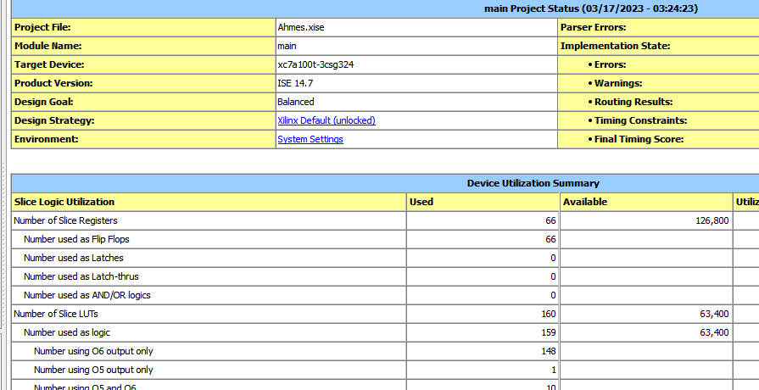

**PASSO 2:** 3 pontos

Descrever a parte de controle do AHMES em VHDL como uma maquina de estados.

Dada as tabelas com as instruções do Neander por estado da máquina de estrados

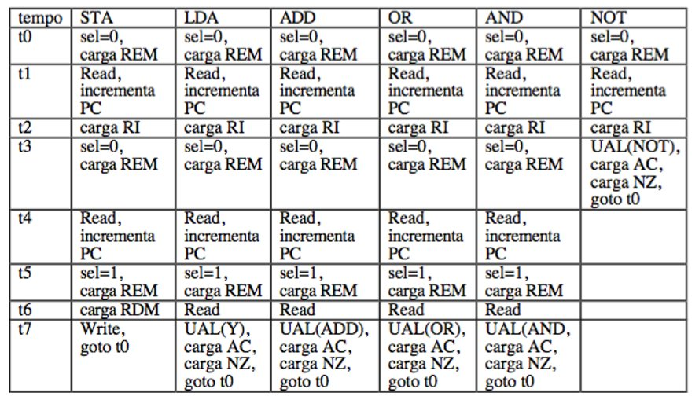

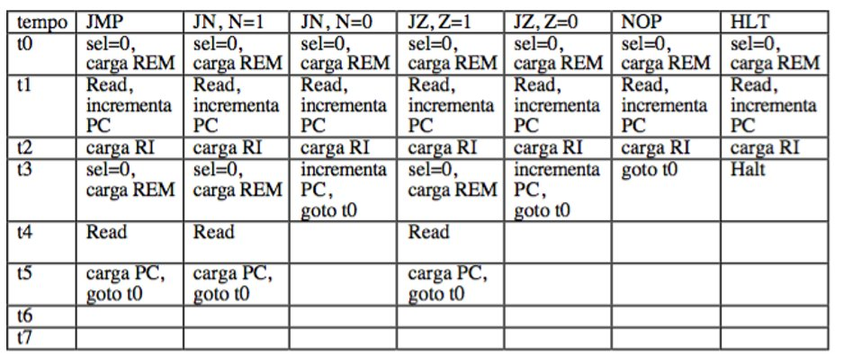

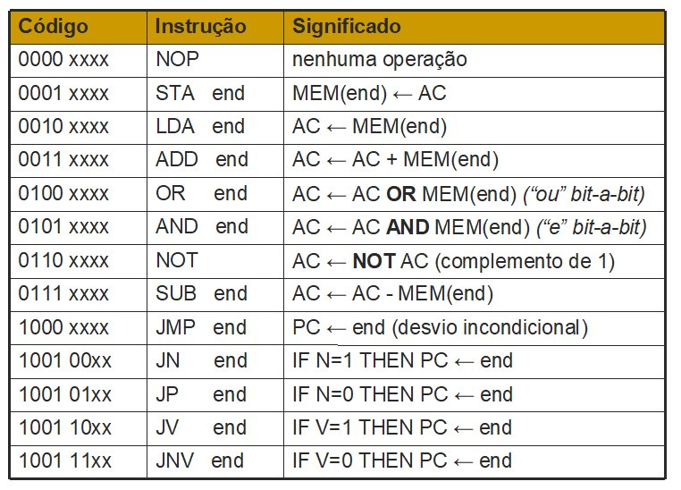

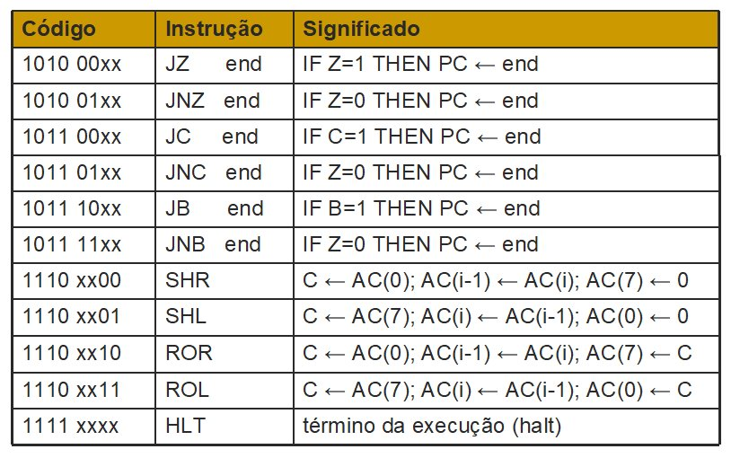

Completar a tabela a seguir com as instruções AHMES que não tem no NEANDER

| Tempo | SHR | SHL | ROR | ROL | SUB |  |  |
| --- | --- | --- | --- | --- | --- | --- | --- |
| T0 |  |  |  |  |  |  |  |
| T1 |  |  |  |  |  |  |  |
| T2 |  |  |  |  |  |  |  |
| T3 |  |  |  |  |  |  |  |
| T4 |  |  |  |  |  |  |  |
| T5 |  |  |  |  |  |  |  |
| T6 |  |  |  |  |  |  |  |
| T7 |  |  |  |  |  |  |  |

E as instruções novas de Desvio

| Tempo |  |  |  |  |  |  |  |
| --- | --- | --- | --- | --- | --- | --- | --- |
| T0 |  |  |  |  |  |  |  |
| T1 |  |  |  |  |  |  |  |
| T2 |  |  |  |  |  |  |  |
| T3 |  |  |  |  |  |  |  |
| T4 |  |  |  |  |  |  |  |
| T5 |  |  |  |  |  |  |  |
| T6 |  |  |  |  |  |  |  |
| T7 |  |  |  |  |  |  |  |

Cole aqui o VHDL da parte de controle usando FSM com dois process.

library ieee;

use ieee.std_logic_1164.all;

use ieee.numeric_std.all;

entity control is

Port(

CLOCK: in std_logic;

RESET: in std_logic;

instruction_flags: in std_logic_vector(23 downto 0);

-- ALU flags

reg_N: in std_logic;

reg_Z: in std_logic;

reg_V: in std_logic;

reg_C: in std_logic;

reg_B: in std_logic;

-- register control outputs

inc_PC: out std_logic;

load_AC: out std_logic;

load_PC: out std_logic;

load_MA: out std_logic;

load_MD: out std_logic;

load_I: out std_logic;

load_N: out std_logic;

load_Z: out std_logic;

load_V: out std_logic;

load_C: out std_logic;

load_B: out std_logic;

-- selectors

sel_MUX_MAR: out std_logic_vector(0 downto 0);

sel_MUX_MDR: out std_logic_vector(0 downto 0);

sel_ALU: out std_logic_vector(3 downto 0);

-- memory control

mem_read: out std_logic_vector(0 downto 0);

mem_write: out std_logic_vector(0 downto 0));

end control;

architecture Behavioral of control is

type state_type is (S0, S1, S2, S3, S4, S5, S6, S7, S8, S9, S10, S11);

signal next_state, current_state: state_type;

-- intruction signals to be used with instruction_flags slices

signal oNOP: std_logic;

signal oSTA: std_logic;

signal oLDA: std_logic;

signal oADD: std_logic;

signal oOR: std_logic;

signal oAND: std_logic;

signal oNOT: std_logic;

signal oSUB: std_logic;

signal oJN: std_logic;

signal oJP: std_logic;

signal oJV: std_logic;

signal oJNV: std_logic;

signal oJZ: std_logic;

signal oJNZ: std_logic;

signal oJC: std_logic;

signal oJNC: std_logic;

signal oJB: std_logic;

signal oJNB: std_logic;

signal oSHR: std_logic;

signal oSHL: std_logic;

signal oROR: std_logic;

signal oROL: std_logic;

signal oHLT: std_logic;

-- ALU operation constants

constant ALUNOP: std_logic_vector(3 downto 0):= "0000";

constant ALUADD: std_logic_vector(3 downto 0):= "0001";

constant ALUOR: std_logic_vector(3 downto 0):= "0010";

constant ALUAND: std_logic_vector(3 downto 0):= "0011";

constant ALUNOT: std_logic_vector(3 downto 0):= "0100";

constant ALUSUB: std_logic_vector(3 downto 0):= "0101";

constant ALUSHR: std_logic_vector(3 downto 0):= "0110";

constant ALUSHL: std_logic_vector(3 downto 0):= "0111";

constant ALUROR: std_logic_vector(3 downto 0):= "1000";

constant ALUROL: std_logic_vector(3 downto 0):= "1001";

constant ALUY: std_logic_vector(3 downto 0):= "1010";

begin

-- hw connections (slices instruction_flags to internal instruction signals)

oNOP <= instruction_flags(0);

oSTA <= instruction_flags(1);

oLDA <= instruction_flags(2);

oADD <= instruction_flags(3);

oOR <= instruction_flags(4);

oAND <= instruction_flags(5);

oNOT <= instruction_flags(6);

oSUB <= instruction_flags(7);

oJN <= instruction_flags(9);

oJP <= instruction_flags(10);

oJV <= instruction_flags(11);

oJNV <= instruction_flags(12);

oJZ <= instruction_flags(13);

oJNZ <= instruction_flags(14);

oJC <= instruction_flags(15);

oJNC <= instruction_flags(16);

oJB <= instruction_flags(17);

oJNB <= instruction_flags(18);

oSHR <= instruction_flags(19);

oSHL <= instruction_flags(20);

oROR <= instruction_flags(21);

oROL <= instruction_flags(22);

oHLT <= instruction_flags(23);

SC: process(CLOCK, RESET) -- FSM state control

begin

if(RESET = '1') then

current_state <= S0;

elsif(rising_edge(CLOCK)) then

current_state <= next_state;

end if;

end process;

FSM: process(

current_state,

-- value flags

reg_N,

reg_Z,

reg_V,

reg_C,

reg_B,

-- instruction flags

oNOP,

oSTA,

oLDA,

oADD,

oOR,

oAND,

oNOT,

oSUB,

oJN,

oJP,

oJV,

oJNV,

oJZ,

oJNZ,

oJC,

oJNC,

oJB,

oJNB,

oSHR,

oSHL,

oROR,

oROL,

oHLT)

-- FSM description

begin

-- resets signals

inc_PC <= '0';

load_AC <= '0';

load_PC <= '0';

load_MA <= '0';

load_MD <= '0';

load_I <= '0';

load_N <= '0';

load_Z <= '0';

load_V <= '0';

load_C <= '0';

load_B <= '0';

sel_MUX_MAR <= "0";

sel_MUX_MDR <= "0";

mem_write <= "0";

mem_read <= "0";

sel_ALU <= ALUNOP; -- default ALU operation

case current_state is

when S0 => -- POINTS

-- updates memory cursor

sel_MUX_MAR <= "0"; -- reg_MA <= reg_PC

load_MA <= '1'; -- updates MAR

-- goto S1

next_state <= S1;

when S1 => -- SKIP

-- goto S2

next_state <= S2;

when S2 => -- READS

-- reads byte from memory updating MD

mem_read <= "1";

sel_MUX_MDR <= "0"; -- reg_MD <= mem_out

load_MD <= '1';

-- increments reg_PC

inc_PC <= '1'; -- adjusts memory cursor and program counter

-- goto S3

next_state <= S3;

when S3 => -- FETCH

-- fetches new instruction

load_I <= '1'; -- reg_I <= reg_MD

-- goto s3

next_state <= S4;

when S4 => -- INS/POINT

if(oNOP = '1') then

-- goto S0

next_state <= S0;

elsif(oNOT = '1') then

-- updates ALU operation

sel_ALU <= ALUNOT;

-- updates AC value

load_AC <= '1';

-- updates flag signals

load_N <= '1';

load_Z <= '1';

load_V <= '1';

load_C <= '1';

load_B <= '1';

-- goto S0

next_state <= S0;

elsif(oJN = '1' and reg_N = '0') then -- JN if n=0

-- conditions does not match for jumping to given addres

-- goes to the next instruction, going to S0

inc_PC <= '1';

next_state <= S0;

elsif(oJP = '1' and reg_N = '1') then -- JP if n=1

-- conditions does not match for jumping to given addres

-- goes to the next instruction, going to S0

inc_PC <= '1';

next_state <= S0;

elsif(oJV = '1' and reg_V = '0') then -- JV if v=0

-- conditions does not match for jumping to given addres

-- goes to the next instruction, going to S0

inc_PC <= '1';

next_state <= S0;

elsif(oJNV = '1' and reg_V = '1') then -- JNV if v=1

-- conditions does not match for jumping to given addres

-- goes to the next instruction, going to S0

inc_PC <= '1';

next_state <= S0;

elsif(oJZ = '1' and reg_Z = '0') then -- JZ if z=0

-- conditions does not match for jumping to given addres

-- goes to the next instruction, going to S0

inc_PC <= '1';

next_state <= S0;

elsif(oJNZ = '1' and reg_Z = '1') then -- JNZ if z=1

-- conditions does not match for jumping to given addres

-- goes to the next instruction, going to S0

inc_PC <= '1';

next_state <= S0;

elsif(oJC = '1' and reg_C = '0') then -- JC if c=0

-- conditions does not match for jumping to given addres

-- goes to the next instruction, going to S0

inc_PC <= '1';

next_state <= S0;

elsif(oJNC = '1' and reg_C = '1') then -- JNC if c=1

-- conditions does not match for jumping to given addres

-- goes to the next instruction, going to S0

inc_PC <= '1';

next_state <= S0;

elsif(oJB = '1' and reg_B = '0') then -- JB if b=0

-- conditions does not match for jumping to given addres

-- goes to the next instruction, going to S0

inc_PC <= '1';

next_state <= S0;

elsif(oJNB = '1' and reg_B = '1') then -- JNB if b=1

-- conditions does not match for jumping to given addres

-- goes to the next instruction, going to S0

inc_PC <= '1';

next_state <= S0;

elsif(oSHR = '1') then -- SHR

-- updates ALU instruction

sel_ALU <= ALUSHR;

-- updates accumulator value

load_AC <= '1';

-- updates logic flag signals

load_N <= '1';

load_Z <= '1';

load_V <= '1';

load_C <= '1';

load_B <= '1';

-- goes to S0

next_state <= S0;

elsif(oSHL = '1') then -- SHL

-- updates ALU instruction

sel_ALU <= ALUSHL;

-- updates accumulator value

load_AC <= '1';

-- updates logic flag signals

load_N <= '1';

load_Z <= '1';

load_V <= '1';

load_C <= '1';

load_B <= '1';

-- goes to S0

next_state <= S0;

elsif(oROR = '1') then -- ROR

-- updates ALU instruction

sel_ALU <= ALUROR;

-- updates accumulator value

load_AC <= '1';

-- updates logic flag signals

load_N <= '1';

load_Z <= '1';

load_V <= '1';

load_C <= '1';

load_B <= '1';

-- goes to S0

next_state <= S0;

elsif(oROL = '1') then -- ROL

-- updates ALU instruction

sel_ALU <= ALUROL;

-- updates accumulator value

load_AC <= '1';

-- updates logic flag signals

load_N <= '1';

load_Z <= '1';

load_V <= '1';

load_C <= '1';

load_B <= '1';

-- goes to S0

next_state <= S0;

elsif(oHLT = '1') then -- HLT

-- goto S8 (loop state)

next_state <= S8;

else

-- for any sucessful jumping instruction and others

-- sets memory cursor position to current reg_PC value

sel_MUX_MAR <= "0"; -- reg_MA <= reg_PC

load_MA <= '1'; -- updates reg_MA with reg_PC

sel_MUX_MDR <= "1";

next_state <= S5;

end if;

when S5 => -- SKIP

-- goto S6

next_state <= S6;

when S6 => -- SKIP

-- reads a new byte from memory

mem_read <= "1";

sel_MUX_MDR <= "0"; -- reg_MD <= mem_out

load_MD <= '1'; -- updates memory data register

-- increments reg_PC for any of the following instructions

if(oSTA = '1' or oLDA = '1' or oADD = '1' or oOR = '1' or oAND = '1' or oSUB = '1') then

inc_PC <= '1';

else

inc_PC <= '0';

end if;

-- goes to S7

next_state <= S7;

when S7 => -- POINT

if(oSTA = '1' or oLDA = '1' or oADD = '1' or oOR = '1' or oAND = '1' or oSUB = '1') then

sel_MUX_MAR <= "1"; -- reg_MA <= reg_MD

load_MA <= '1'; -- updates reg_MA value

-- goto S8

next_state <= S8;

else -- for any other instruction (jumps)

-- updates program counter

load_PC <= '1';

-- goto S0

next_state <= S0;

end if;

when S8 => -- SKIP

next_state <= S9;

when S9 => -- READ

if(oSTA = '1') then -- STA

sel_MUX_MDR <= "1"; -- reg_MD <= reg_AC

load_MD <= '1'; -- updates reg_MD value

else

-- for any other instruction

mem_read <= "1";

sel_MUX_MDR <= "0"; -- reg_MD <= mem_out

load_MD <= '1'; -- updates MD value

end if;

-- goto s10

next_state <= S10;

when S10 => -- INS

if(oSTA = '1') then

mem_write <= "1";

-- goto S0

next_state <= S0;

elsif(oLDA = '1') then

-- updates ULA_out and by consequence the accumulator with reg_MD

load_AC <= '1';

-- updates value flag registers

load_N <= '1';

load_Z <= '1';

load_V <= '1';

load_C <= '1';

load_B <= '1';

-- updates ALU instruction

sel_ALU <= ALUY;

-- goto S0

next_state <= S0;

elsif(oADD = '1') then

-- updates ALU instruction

sel_ALU <= ALUADD;

-- updates the accumulator with ULA_out

load_AC <= '1';

-- updates value flag registers

load_N <= '1';

load_Z <= '1';

load_V <= '1';

load_C <= '1';

load_B <= '1';

-- goto S0

next_state <= S0;

elsif(oOR = '1') then

-- updates ALU instruction

sel_ALU <= ALUOR;

-- updates the accumulator with ULA_out

load_AC <= '1';

-- updates value flag registers

load_N <= '1';

load_Z <= '1';

load_V <= '1';

load_C <= '1';

load_B <= '1';

-- goto S0

next_state <= S0;

elsif(oAND = '1') then

-- updates ALU instruction

sel_ALU <= ALUAND;

-- updates the accumulator with ULA_out

load_AC <= '1';

-- updates value flag registers

load_N <= '1';

load_Z <= '1';

load_V <= '1';

load_C <= '1';

load_B <= '1';

-- goto S0

next_state <= S0;

elsif(oSUB = '1') then

-- updates ALU instruction

sel_ALU <= ALUSUB;

-- updates the accumulator with ULA_out

load_AC <= '1';

-- updates value flag registers

load_N <= '1';

load_Z <= '1';

load_V <= '1';

load_C <= '1';

load_B <= '1';

-- goto S0

next_state <= S0;

else

-- invalid instruction

next_state <= S11;

end if;

when S11 => -- HALT

-- loop state (HALT)

next_state <= S10;

when others => -- HALT

next_state <= S10;

end case;

end process;

end Behavioral;

**PASSO 3:** 1 ponto

Descrever o programa em Assembly do AHMES que realize a multiplicação de dois números inteiros positivos de 8 bits por Deslocamento e soma em binário e colocar no arquivo .COE na memória BRAM.

Inserir aqui o programa em Assembly com explicação

; programa multiplicação 10x2

LDA 128

SHL

HLT

ORG 128

Cte_10:

DB 10

Por deslocamento:  
memory_initialization_radix=10;

memory_initialization_vector=0,32,128,225,240,0,0,0,0,0,0,0,0,0,0,0,0,0,0,0,0,0,0,0,0,0,0,0,0,0,0,0,0,0,0,0,0,0,0,0,0,0,0,0,0,0,0,0,0,0,0,0,0,0,0,0,0,0,0,0,0,0,0,0,0,0,0,0,0,0,0,0,0,0,0,0,0,0,0,0,0,0,0,0,0,0,0,0,0,0,0,0,0,0,0,0,0,0,0,0,0,0,0,0,0,0,0,0,0,0,0,0,0,0,0,0,0,0,0,0,0,0,0,0,0,0,0,0,10,0,0,0,0,0,0,0,0,0,0,0,0,0,0,0,0,0,0,0,0,0,0,0,0,0,0,0,0,0,0,0,0,0,0,0,0,0,0,0,0,0,0,0,0,0,0,0,0,0,0,0,0,0,0,0,0,0,0,0,0,0,0,0,0,0,0,0,0,0,0,0,0,0,0,0,0,0,0,0,0,0,0,0,0,0,0,0,0,0,0,0,0,0,0,0,0,0,0,0,0,0,0,0,0,0,0,0,0,0,0,0,0,0,0,0,0,0,0,0,0,0,0,0,0,0,0,0;

; programa multiplicação 10x2

LDA 128

ADD cte_10

HLT

ORG 128

Cte_10:

DB 10

Por somas sucessivas:

memory_initialization_radix=10;

memory_initialization_vector=0,32,128,48,128,240,0,0,0,0,0,0,0,0,0,0,0,0,0,0,0,0,0,0,0,0,0,0,0,0,0,0,0,0,0,0,0,0,0,0,0,0,0,0,0,0,0,0,0,0,0,0,0,0,0,0,0,0,0,0,0,0,0,0,0,0,0,0,0,0,0,0,0,0,0,0,0,0,0,0,0,0,0,0,0,0,0,0,0,0,0,0,0,0,0,0,0,0,0,0,0,0,0,0,0,0,0,0,0,0,0,0,0,0,0,0,0,0,0,0,0,0,0,0,0,0,0,0,10,0,0,0,0,0,0,0,0,0,0,0,0,0,0,0,0,0,0,0,0,0,0,0,0,0,0,0,0,0,0,0,0,0,0,0,0,0,0,0,0,0,0,0,0,0,0,0,0,0,0,0,0,0,0,0,0,0,0,0,0,0,0,0,0,0,0,0,0,0,0,0,0,0,0,0,0,0,0,0,0,0,0,0,0,0,0,0,0,0,0,0,0,0,0,0,0,0,0,0,0,0,0,0,0,0,0,0,0,0,0,0,0,0,0,0,0,0,0,0,0,0,0,0,0,0,0,0;

**PASSO 4:** 3 pontos

Simular sem atraso o AHMES com um programa teste a ser feito pelo aluno e depois que testado e funcionando, simular com o programa do passo 3. Depois de tudo funcionando, simular também com atraso.

Lembrem-se que deve ser feito um testbench para a simulação.

Colar aqui o programa teste e simulações (.JPG)

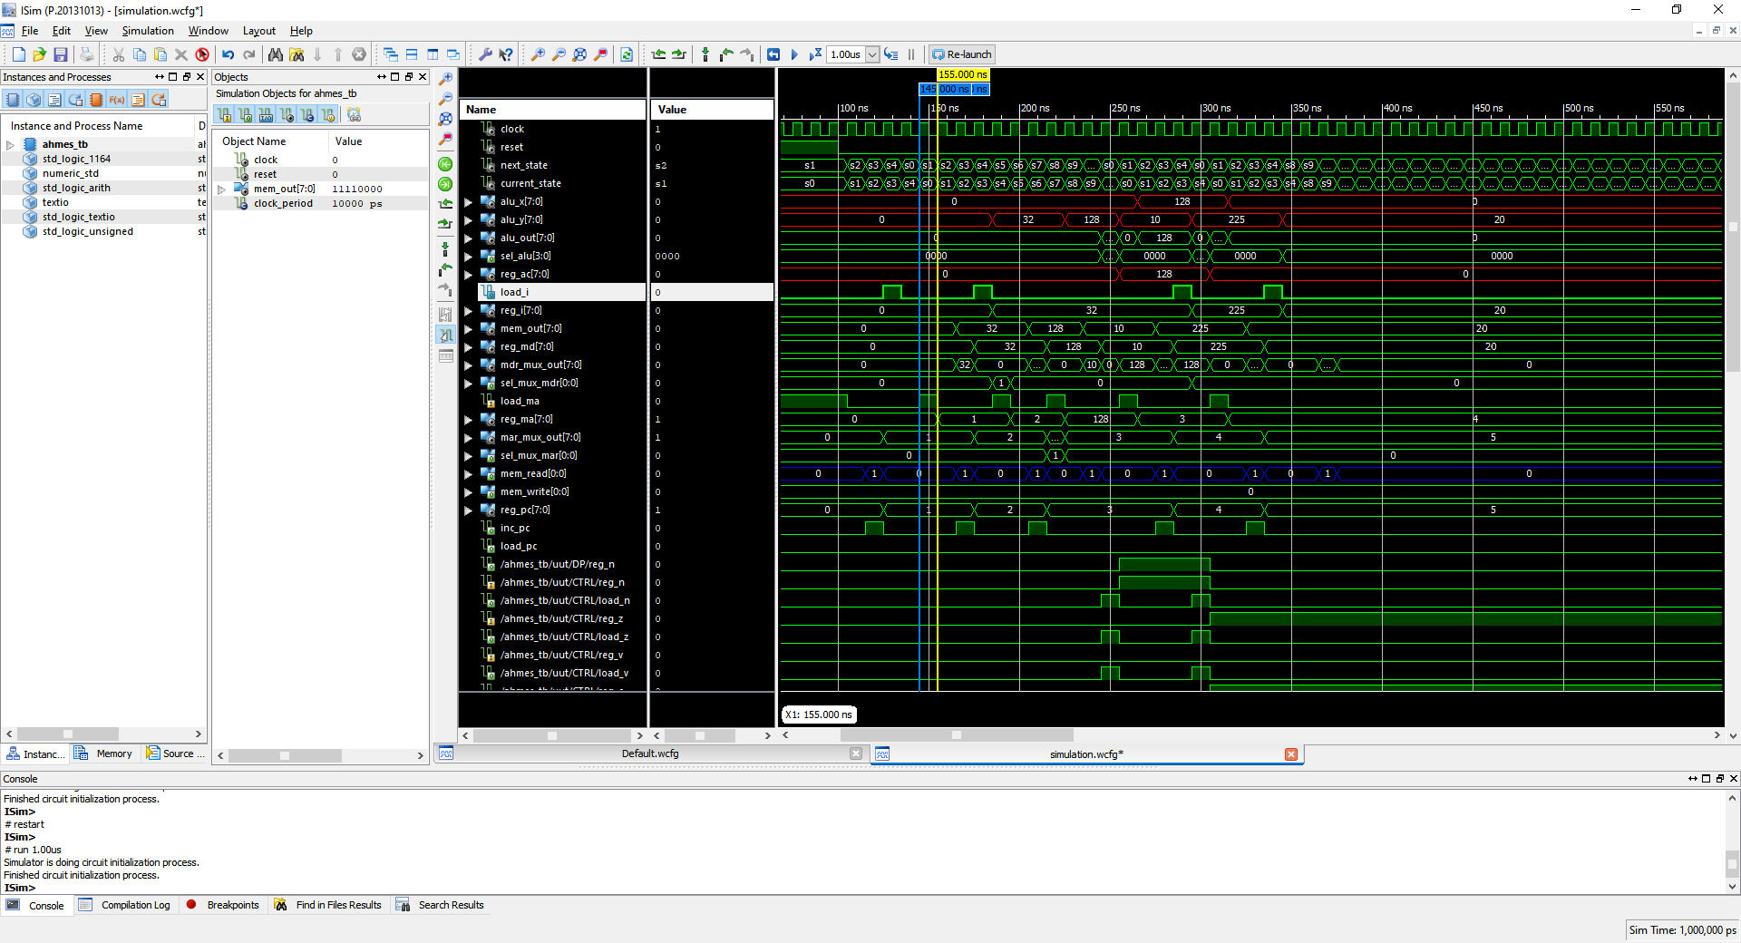

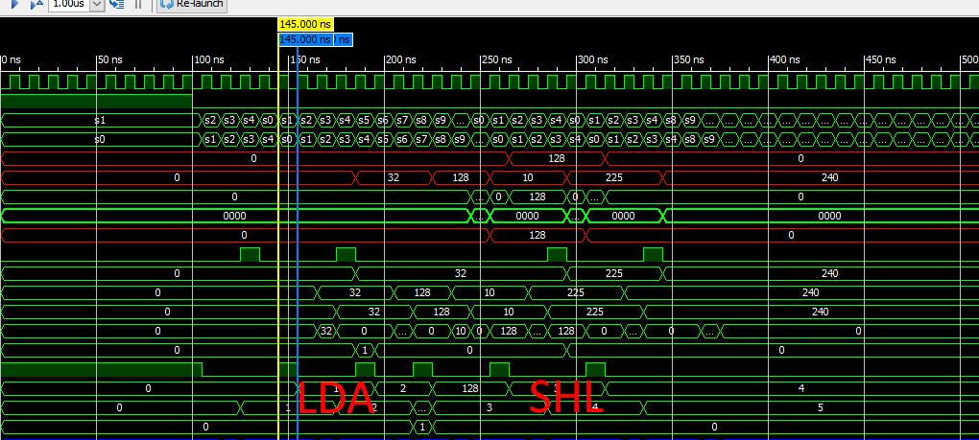

**Quantos ciclos de relógio foram necessários para a execução do programa de multiplicação no AHMES?** 38 c.c (programa anterior – até atingir o HLT)